

Brand and style guide
How Jube looks, sounds and writes, across the product, the website, the documentation and our documents.
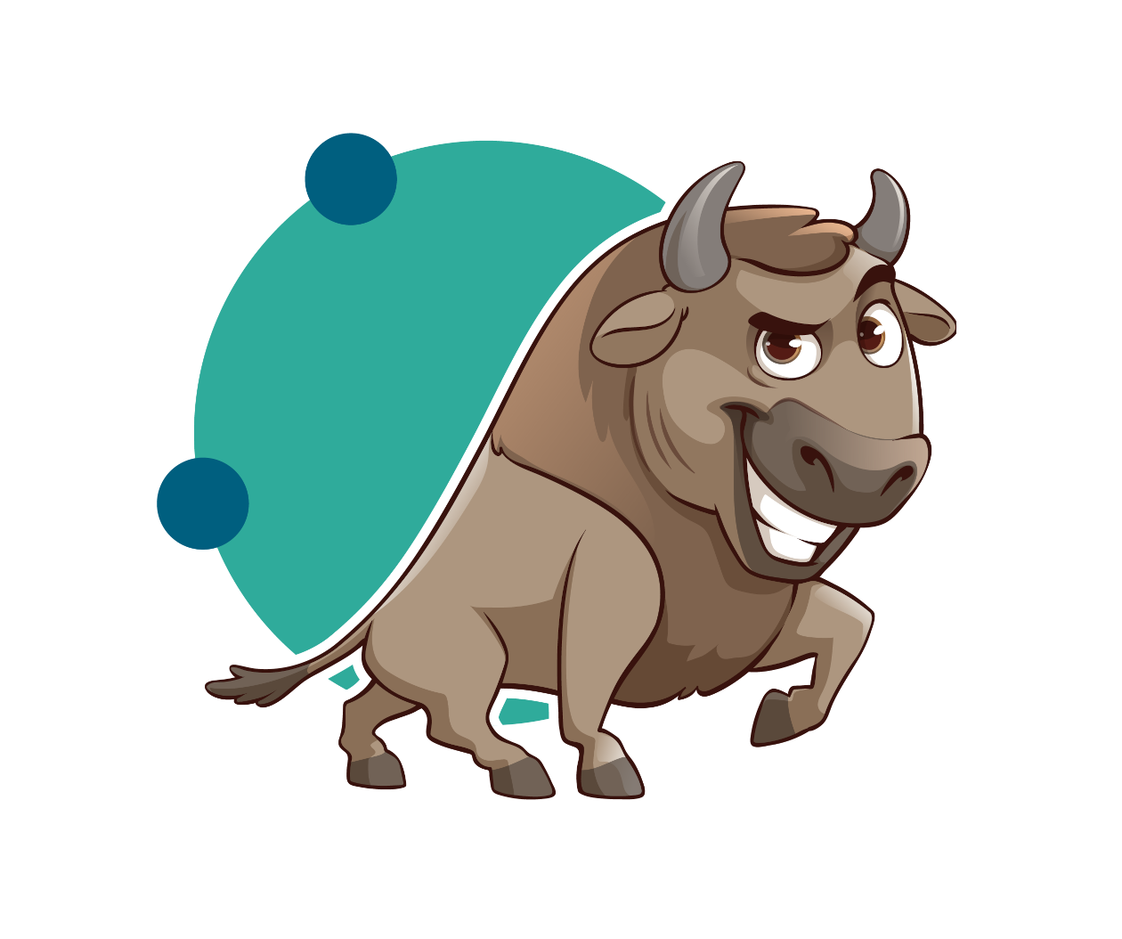
Jube Holdings Limited · Version 1.0 · 4 October 2026

1. The brand in one page
What Jube is. Open-source, real-time anti-money-laundering and fraud transaction monitoring, with AI on every screen and the detection platform underneath it.

What we stand for
- Open. Every feature is open source under AGPLv3. Nothing is held back.
- Explainable. Every score, rule and AI answer can be walked through with a regulator.
- Sovereign. Customers run Jube on their own infrastructure, in their own jurisdiction.
- AI-first, on our own platform. AskJooby reasons over the same models and data that made the decision.

How we sound
Plain, exact and calm. We write for compliance officers, analysts and engineers who are busy and sceptical. We state facts, give numbers, and never oversell.

2. Logo
The wordmark is the logo. Use it from the supplied PNG or SVG files; never retype it.
Rule | Detail
Colour | Jube Navy on white or light backgrounds. White on Jube Navy. Nothing else.
Clear space | On every side, at least half the height of the wordmark.
Minimum size | 24 px high on screen; 8 mm high in print.
Placement | Top left of documents and pages; top left of the product shell.
Never | Stretch, rotate, outline, add shadows, recolour, place on photos or busy backgrounds, or set "Jube" in another font as a logo.

3. The Jube buffalo
The buffalo is our mascot. It adds warmth where people meet Jube for the first time.
Use it on | Do not use it on
Covers of guides and proposals; training material; the website; social posts; empty states and onboarding | Product screens where people make decisions; reports to regulators; anywhere it would sit beside a case, a payment or a customer

- Use the supplied artwork only. Never redraw, crop the buffalo, change its colours or add speech.
- Minimum width 30 mm in print, 120 px on screen.
- One buffalo per page.

4. Colour
Two brand colours, three neutrals and one signal colour. Most of any page is white and ink; colour is used to mark, not to decorate.
 | Name | HEX | RGB | Use
 | Jube Navy | #005F7F | 0, 95, 127 | Logo, headings, links, primary buttons
 | Jube Teal | #2FAB9B | 47, 171, 155 | Accents, rules, highlights. Not for text on white
 | Ink | #23221F | 35, 34, 31 | Body text
 | Slate | #4A4842 | 74, 72, 66 | Secondary text, captions
 | Stone | #CFCCC4 | 207, 204, 196 | Lines and table borders
 | Mist | #F4F3EF | 244, 243, 239 | Table headers, panels
 | Signal Red | #B42318 | 180, 35, 24 | Risk only: high risk, confirmed fraud, errors

- Text is Ink or Navy on white, or white on Navy. Both pass WCAG AA.
- Teal on white is too light for text; use it for shapes and lines.
- Red means risk and nothing else. Never use it for emphasis or branding.
- The buffalo's browns belong to the mascot artwork only.

5. Typography
IBM Plex Sans for everything we write; IBM Plex Mono for identifiers, code and data. Both are free, open source and available in Google Docs, Word and on the web.
Element | Font | Size in documents | Notes
Title | IBM Plex Sans SemiBold | 28 pt, Navy | Covers only
Heading 1 | IBM Plex Sans SemiBold | 18 pt, Navy | Numbered: 1, 2, 3
Heading 2 | IBM Plex Sans SemiBold | 13 pt, Ink
Body | IBM Plex Sans | 11 pt, Ink | Line spacing 1.15; 6 pt after paragraphs
Caption | IBM Plex Sans | 9 pt, Slate | Below figures: "Fig. 3 · Cases page"
Data and code | IBM Plex Mono | 10 pt | Case ids, field names, endpoints: C-9041, GET /api/Me

- Sentence case for every heading and button: "Decide payment", not "Decide Payment".
- Bold for the few words a reader must not miss. No underlines except links. No italics for emphasis.
- Never use more than two sizes of heading on a page.

6. Writing

Principles
- Lead with the point. The first sentence says what happened or what to do.
- Be exact. "EGP 48,500 to a new payee, 41 s after login", not "a suspicious payment".
- Show the evidence. Every claim can be traced to a fact, a source or a number.
- Short sentences, common words. Explain a term the first time you use it.
- Calm, never alarming. State risk plainly; no exclamation marks, no hype.

House rules
Topic | Rule | Example
Spelling | British English | colour, authorise, licence (noun)
Dates | Day, month name, year | 4 October 2026; 4 Oct in tables
Times | 24-hour, with seconds only when they matter | 10:14, 10:14:55
Money | Currency code, space, amount with commas | EGP 25,000; GBP 85,000
Numbers | Numerals for 10 and above and all measurements | 9 days, 11 deposits, 56%
Lists | Sentence case; full stop only if items are sentences | See this list
Buttons | Verb first, sentence case, two or three words | Release payment; Add as fact
Errors | What happened, then what to do | "Payment system unavailable since 08:41. Try again when it is back."

7. Names and terms
Write | Not | Notes
Jube | JUBE, jube | The wordmark is capitals; in text it is "Jube"
Jube v2 | Jube 2.0, Jube V2
open source; open-source software | opensource, Open Source | Hyphenate only before a noun
AML and fraud | fraud and AML | In that order
AskJooby | Ask Jooby, Askjooby, the chatbot | The product. In a sentence the assistant is "Jooby"
Bites | bites, Jooby Bites | Short AskJooby narratives in case work
Analyst Agent, Rule Writer, Researcher | analyst agent | AskJooby personas, title case
Exhaustive adaptation | exhaustive learning | Jube's model training
case, hold, release, refuse, suppression | ticket, block, approve payment | Use the product's words

8. In the product
- Built with daisyUI themes: primary is Jube Navy, accent is Jube Teal, both in light and dark.
- Icons are Lucide, outline style, at text size.
- Colour means state. Red is risk only; amber is a deadline; green is confirmed. Every state also has a word or icon, never colour alone.
- Identifiers and amounts use IBM Plex Mono with tabular figures.
- AI output is always labelled: "Drafted by Jooby", "Bite", or a Finding card with its sources.

9. Documents and slides

Documents (Google Docs and Word)
- A4, 2 cm margins. Use the built-in Title, Heading 1, Heading 2 and Normal text styles; never format headings by hand.
- Cover: wordmark top left, title, one-line subtitle, optionally the buffalo, then author, date and status.
- Header from page 2: the wordmark small on the left, the document title on the right.
- Figures inline, full text width, with a caption below. Tables have a Mist header row and Stone borders.
- No text boxes, columns or floating images; they do not survive Google Docs.

Slides
- 16:9, white background, Navy titles, one idea per slide.
- Text at least 24 pt. A number, a screenshot or a short list, not all three.
- Teal for a single accent line or shape per slide.

10. Before you publish
- The wordmark is the supplied file, with clear space, in Navy or white.
- Only the colours in section 4; red only for risk.
- IBM Plex Sans and Plex Mono only.
- Headings in sentence case; British spelling; dates as 4 October 2026.
- Every number and claim can be traced to its source.
- AI-written text is labelled.

